**12U CABINET RACK 19" CABINET 600X600 | 12U ENCLOSURE FLOOR STANDING**

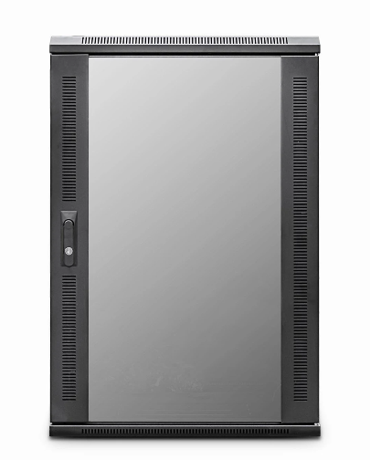

**CAB-FE-12U-66**

**DESCRIPTION**

Redefining Quality And Ergonomics In Small-Scale Network Deployment

Looking to deploy a small height data or telco cabinet but need the

advantages of a full height cabinet?

The newly design EcoNetCab 12U Cabinet Rack and 15U floor-standing cabinets are ideal for

many installations that need all the advantages for full width, 19-inch racking,

full depth, adjustable mount posts and of course FREE, bundled cabinet accessories

including Fan Tray, vented shelf, castors and jacking feet for example.

With more networking, telco, PBX and broadcast equipment becoming more

compact and of course thinking all installations do not require a high,

towering 42U cabinet for example, the new EcoNetCab 112U Cabinet Rack and 15U range are ideal for IT rooms, PBX switching centres, SME business applications, but without the extra height clearance that other models need.

Superb-build quality of course is assured, multiple cable entries, together

with left/right hinged safety-glass door as standard, together with a hard-wearing

black, powder-coated finish and assembled here in the UK.

**SPECIFICATIONS**

* 12U high 600W 600D
* ETSI 19” front/rear profiles, adjustable
* Lockable vented glass door, reversible
* Removable side panels, rear lockable door
* Ideal for SME, IT Rooms, PBX & Broadcast
* 2-Way Low Noise Fan Tray Fitted
* Fitted Vented Shelf, Jacking Feet/Castors (4)
* UK Assembled and quality assured
* Dimensions: 600 (width) x 600 (depth) x720mm (height)